EBPR
Publicity
Marketing
Literary Consultation

FOR IMMEDIATE RELEASE
Contact: Emi Battaglia
emi@emibattaglia.com

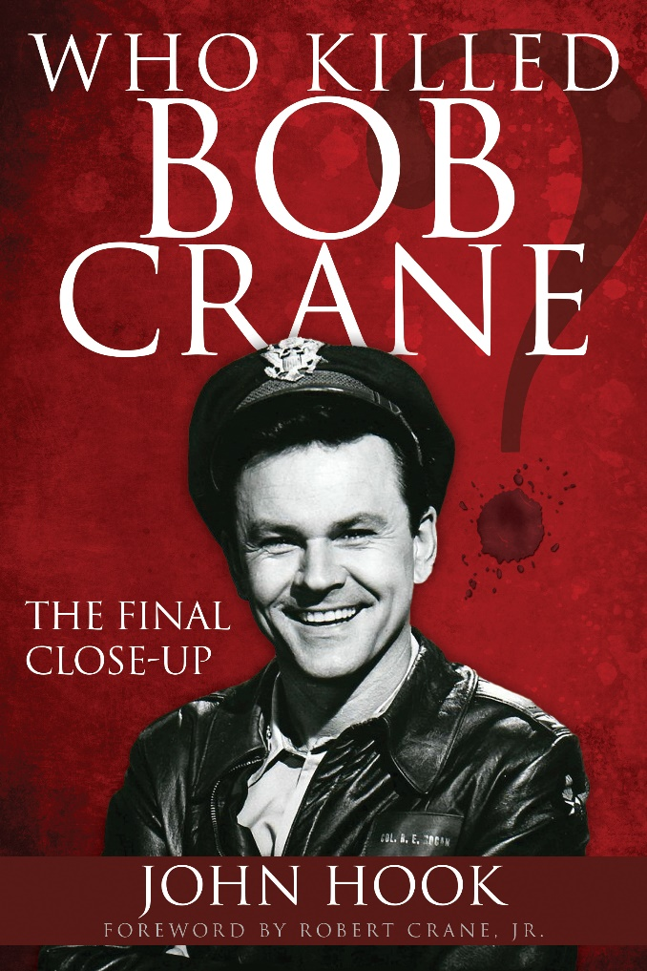
In WHO KILLED BOB CRANE? (Trade Paperback original; February 21, 2017; $17.95) John Hook tells the story of how he became immersed in re-investigating the murder of the Hogan’s Heroes TV star, a murder that has remained a tantalizing, agonizing mystery for nearly 40 years. On the afternoon of June 29, 1978, Bob Crane’s dead body was found in bed in his Scottsdale apartment, curled in a semi-fetal sleeping position, his battered head resting partially on a blood-soaked pillow with a black electrical cord tied around his neck. Police quickly narrowed in on a suspect: video whiz John Carpenter, Crane’s close friend and partner in sordid womanizing. In 1994, Carpenter was finally brought to trial. But DNA results were inconclusive, resulting in Carpenter’s acquittal. Three decades later, Hook pulled off an extraordinary journalistic feat; securing permission to retest the last of the DNA blood-evidence in this cold case murder. Delivering shocking new DNA results that cast doubt on the identity of the killer and upending long held police beliefs, Hook takes readers on an incredible reporters journey for an inside look at the sensational physical evidence in a final attempt to learn the truth about one of the most shocking true crime cases of our times

In June of 1978, John Hook was just 18 years old and looking forward to studying journalism at Arizona State when he turned on the TV to stunning news: Bob Crane, the beloved Hogan’s Heroes star, had been bludgeoned to death, a mere seven miles from Hook’s future dorm. By March of 2015, Hook had become an award-winning news reporter and anchor when he got the opportunity to interview Robert Crane Jr. about his father. That interview rekindled Hook’s fascination with the infamous murder, which consistently ranks as one of the top cold cases of all time and one of the world’s most salacious celebrity tragedies. It also sparked an idea: What if we retested the original blood evidence using modern DNA science?

A memoir wrapped around a true crime thriller, Hook’s debut book delves into crime scene data, police and courtroom records; years of detective work (both rigorous and careless); speculations swirling around Bob Crane’s voracious sexual appetite and passion for videotaping his carnal escapades, as well as his contentious relationship with his wife Patti; and John Carpenter’s odd behavior after the murder. Highlights include:

- Transcripts of never-before-released police interrogations with John Carpenter, in which he comes across as remarkably cordial and composed. “He was either a very good liar,” Hook observes, “or completely innocent.”

- Carpenter’s off-the-cuff admission of guilt to his wife at the time of his 1992 arrest and the first in-depth interview with the jury foreman in the murder trial, offering details into what went on inside the jury room and why the panel voted to acquit.

- Never-before-seen evidence photos, insights into the compromised crime scene and possible skull tissue investigators overlooked, theories about the enigmatic missing murder weapon, and a startling revelation about the traces of blood (Crane’s type, B-positive, claimed by one in ten people) found in Carpenter’s rental car.

About the Author:
Winner of over a dozen Emmy awards for his reporting, JOHN HOOK was named Associated Press Anchor of the Year five times and inducted into the Walter Cronkite School of Journalism Hall of Fame. Based in Phoenix, he anchors FOX 10 News at 5 and 9 and hosts the Emmy Award-winning FOX 10 Newsmaker Sunday.

Who Killed Bob Crane?: The Final Closeup
By John Hook with a Foreword by Robert Crane, Jr.
Published by Get Hooked Media
On Sale: February 21, 2017
Trade Paperback Original: $17.95
ISBN: 978-1944194253
www.whokilledbobcrane.com

